**Benjamin Lorentson – Semester Project Wireframe Templates**

***Home Page***

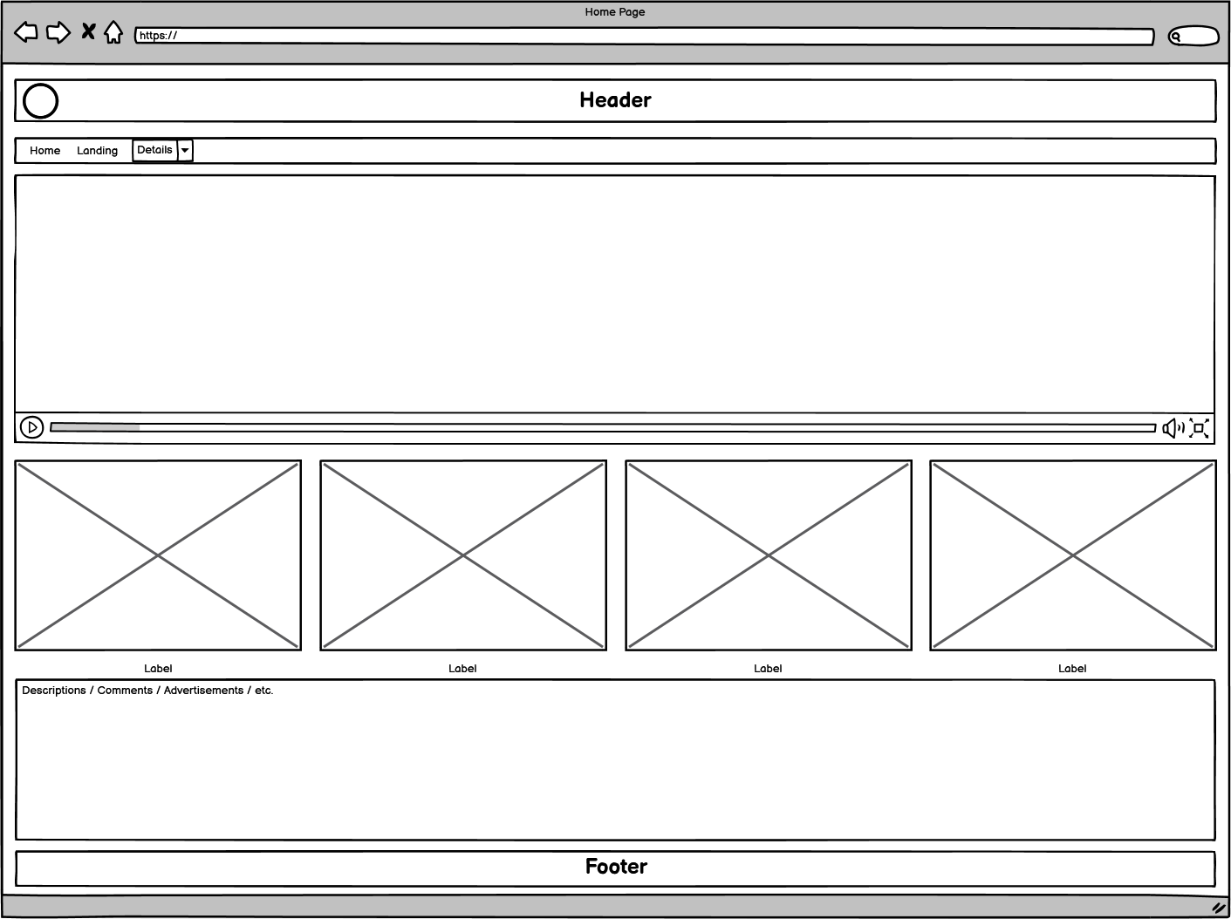

***Landing Page***

***Details Page***

